**Portfolio Milestone - Concurrency with Counting in C++**

Andrew Barnes

Colorado State University Global

CSC450-1

Reginald Haseltine

6/2/2024

**Source Code**

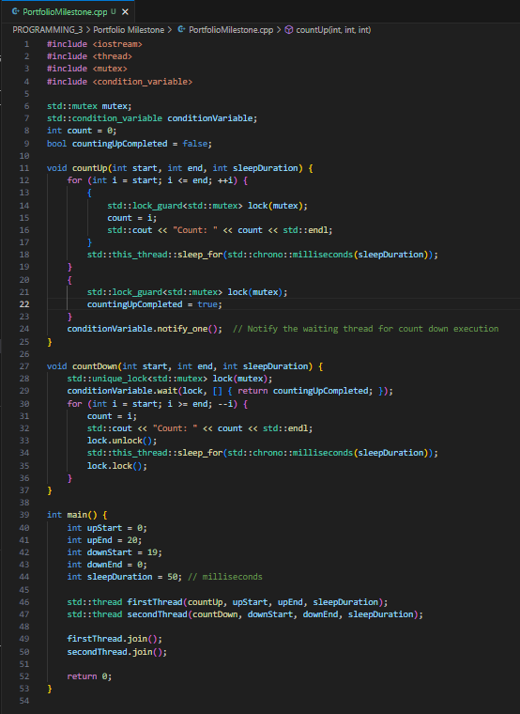

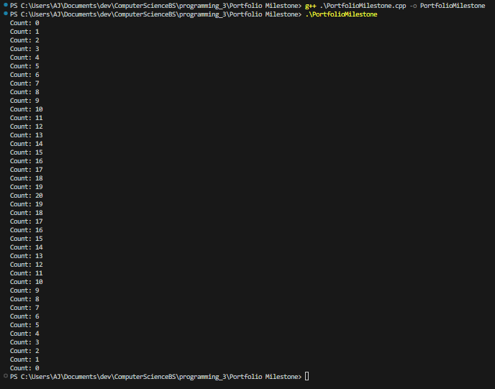

**Git**

